PRACTICAL – 01

AIM: Document Indexing and Retrieval
- Implement an inverted construction algorithm.
- Build a simple document retrieval system using the constructed index.

CODE:

# Define the documents
document1 = "The quick brown fox jumped over the lazy dog ." document2 = "The lazy dog slept in the sun."
# Step 1: Tokenize the documents
# Convert each document to lowercase and split it into words tokens1 = document1.lower().split()
tokens2 = document2.lower().split()
# Combine the tokens into a list of unique terms terms = list(set(tokens1 + tokens2))
# Step 2: Build the inverted index
# Create an empty dictionary to store the inverted index inverted_index = {}
# For each term, find the documents that contain it for term in terms:
documents = []
if term in tokens1: documents.append("Document 1")
if term in tokens2: documents.append("Document 2")
inverted_index[term] = documents # Step 3: Print the inverted index

for term, documents in inverted_index.items(): print(term, "->", ", ".join(documents))

OUTPUT:

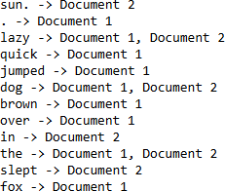

PRACTICAL – 02

AIM: Retrieval Models
- Implement the Boolean retrieval model and process queries.
- Implement the vector space model with TF-IDF weighting and cosine similarity.

CODE-A:

documents = {
1: "apple banana orange", 2: "apple banana",
3: "banana orange",
4: "apple"
}

# Build inverted index (clean & pythonic) def build_index(docs):
index = {}
for doc_id, text in docs.items(): for term in text.split():
index.setdefault(term, set()).add(doc_id) return index

inverted_index = build_index(documents)

# Boolean operations
def boolean_and(terms, index):
sets = [index.get(t, set()) for t in terms]
return list(set.intersection(*sets)) if sets else []

def boolean_or(terms, index):
sets = [index.get(t, set()) for t in terms] return list(set.union(*sets)) if sets else []

def boolean_not(term, index, total_docs):
return list(set(range(1, total_docs + 1)) - index.get(term, set()))

# Queries
print("AND:", boolean_and(["apple", "banana"], inverted_index)) print("OR:", boolean_or(["apple", "orange"], inverted_index)) print("NOT:", boolean_not("orange", inverted_index, len(documents)))

OUTPUT-A:

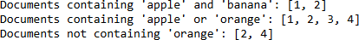

CODE-B:

import math
from collections import Counter

tok = lambda t: t.lower().split()
tf = lambda w: {x: c/len(w) for x, c in Counter(w).items()}
idf = lambda D: {w: math.log(len(D)/sum(w in set(tok(d)) for d in D)) for w in {x for d in D for x in tok(d)}}

tfidf = lambda tf, idf: {w: tf[w]*idf.get(w,0) for w in tf}

cos = lambda a,b: (lambda na,nb: sum(a[w]*b[w] for w in a if w in b)/(na*nb) if na and nb else 0)(
math.sqrt(sum(v*v for v in a.values())), math.sqrt(sum(v*v for v in b.values()))
)

vsm = lambda D,q: (lambda I,Q: [cos(Q, tfidf(tf(tok(d)), I))
for d in D])(
idf(D), tfidf(tf(tok(q)), idf(D))
)

# Example docs = [
"This is the first document.",
"This document is the second document.", "And this is the third one.",

"Is this the first document?",
]

query = "This is a query document." print(vsm(docs, query))

OUTPUT-B:

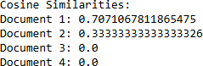

PRACTICAL – 03

AIM: Spelling Correcting in IR System
- Develop a spelling correction module using edit distance algorithms.
- Integrate the spelling correction module into an information retrieval system.

CODE:

import difflib

def correct_spelling(query, dictionary): query = query.lower()
# Find closest matches automatically
return difflib.get_close_matches(query, dictionary, n=5, cutoff=0.5)

dictionary = ["information", "retrieval", "spelling", "correction", "system"]

query = input("Enter your query: ")

suggestions = correct_spelling(query, dictionary)

if suggestions:
print("Did you mean:") for s in suggestions:
print(s)
else:
print("No suggestions found.")

# WITH NO EDIT DISTANCE
import difflib
dictionary = ["information", "retrieval", "spelling", "correction", "system"]
print(difflib.get_close_matches(input("Enter your query: "), dictionary) or "No suggestions found.")

OUTPUT:

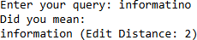

PRACTICAL – 04

AIM: Evaluation Metrics for IR Systems
- Calculate precision, recall, and F-measure for a given set of retrieval results.
- Use an evaluation toolkit to measure average precision and other evaluation metrics.

CODE-A:

def calculate_metrics(retrieved_set, relevant_set):
# Count documents that were retrieved AND are actually relevant (correct hits). true_positive = len(retrieved_set.intersection(relevant_set))

# Count documents that were retrieved but are NOT relevant (wrong hits). false_positive = len(retrieved_set.difference(relevant_set))

# Count documents that are relevant but were NOT retrieved (missed relevant docs). false_negative = len(relevant_set.difference(retrieved_set))

# Print the basic counts so you can see the raw numbers. print("True Positive: ", true_positive,
"\nFalse Positive: ", false_positive, "\nFalse Negative: ", false_negative, "\n")

# Precision = of the items we retrieved, how many were actually relevant? # (true_positive) / (true_positive + false_positive)
precision = true_positive / (true_positive + false_positive)

# Recall = of all relevant items, how many did we successfully retrieve? # (true_positive) / (true_positive + false_negative)

recall = true_positive / (true_positive + false_negative)

# F-measure (F1 score) = harmonic mean of precision and recall. # It balances precision and recall into a single number. f_measure = 2 * precision * recall / (precision + recall)

# Return the three computed metrics so caller can use them. return precision, recall, f_measure

# Example sets:
retrieved_set = set(["doc1", "doc2", "doc3"]) # Documents the system returned relevant_set = set(["doc1", "doc4"]) # Documents that truly are relevant

# Call the function and get the three metrics
precision, recall, f_measure = calculate_metrics(retrieved_set, relevant_set)

# Print the results in readable form print(f"Precision: {precision}") print(f"Recall: {recall}") print(f"F-measure: {f_measure}")

# In[10]:

retrieved = {"doc1", "doc2", "doc3"} relevant = {"doc1", "doc4"}

tp = len(retrieved & relevant) fp = len(retrieved - relevant) fn = len(relevant - retrieved)

precision = tp / (tp + fp) if tp + fp else 0 recall = tp / (tp + fn) if tp + fn else 0
f1 = 2 * precision * recall / (precision + recall) if precision + recall else 0

print(f"True Positive: {tp}, False Positive: {fp}, False Negative: {fn}") print(f"Precision: {precision}, Recall: {recall}, F1-score: {f1}")

OUTPUT-A:
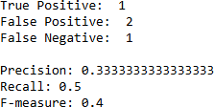

CODE-B:

# Import functions to compute evaluation metrics:
from sklearn.metrics import average_precision_score, precision_recall_curve, auc
from sklearn.metrics import accuracy_score, precision_score, recall_score, f1_score, roc_auc_score

# Import plotting library (to draw the Precision-Recall curve) import matplotlib.pyplot as plt

# Import numpy for numeric operations (we use it to convert lists to arrays) import numpy as np

def calculate_classification_metrics(y_true, y_pred_prob): """
Calculate various classification metrics.

Parameters:
- y_true: True labels (ground truth). e.g., [1, 0, 1] where 1 = positive, 0 = negative
- y_pred_prob: Predicted probabilities for the positive class.
e.g., [0.8, 0.4, 0.9] where each value is a probability between 0 and 1

Returns:
- Dictionary containing different evaluation metrics (this function prints results and plots the Precision-Recall curve).
"""

# Convert probabilities to binary predictions using a threshold of 0.5:

# If probability >= 0.5 -> predict positive (1), else predict negative (0). y_pred_binary = (np.array(y_pred_prob) >= 0.5).astype(int)

# ACCURACY: proportion of all examples that were correctly predicted. # e.g., if 7 out of 10 predictions match the true labels, accuracy = 0.7 accuracy = accuracy_score(y_true, y_pred_binary)

# PRECISION: of all predicted positive examples, how many are actually positive? # precision = TP / (TP + FP)
precision = precision_score(y_true, y_pred_binary)

# RECALL (also called sensitivity): of all actual positive examples, # how many did we successfully find?
# recall = TP / (TP + FN)
recall = recall_score(y_true, y_pred_binary)

# F1 SCORE: harmonic mean of precision and recall. # It balances precision and recall into one number. f1 = f1_score(y_true, y_pred_binary)

# ROC-AUC: area under the ROC curve. It measures how well the model ranks positives # above negatives using predicted probabilities.
# Note: roc_auc_score uses y_pred_prob (not binary predictions). roc_auc = roc_auc_score(y_true, y_pred_prob)

# AVERAGE PRECISION: summary of precision-recall curve that accounts for # different probability thresholds — useful for imbalanced datasets. average_precision = average_precision_score(y_true, y_pred_prob)

# Get the full precision-recall curve:
# precision_curve: precision values at different thresholds # recall_curve: recall values at different thresholds
# thresholds (ignored here) are the probability cutoffs
precision_curve, recall_curve, _ = precision_recall_curve(y_true, y_pred_prob)

# Compute area under the Precision-Recall curve (PR-AUC) using recall on x-axis area_under_pr_curve = auc(recall_curve, precision_curve)

# Print the computed metrics so user can read them print(f'Accuracy: {accuracy}')
print(f'Precision: {precision}') print(f'Recall: {recall}') print(f'F1 Score: {f1}') print(f'ROC-AUC: {roc_auc}')
print(f'Average Precision: {average_precision}')
print(f'Area under Precision-Recall curve: {area_under_pr_curve}')

# PLOT: Draw the Precision-Recall curve to visually inspect model behavior. plt.figure(figsize=(8, 6)) # set figure size
plt.plot(recall_curve, precision_curve, color='blue', lw=2, label='Precision-Recall curve') plt.xlabel('Recall') # x-axis label
plt.ylabel('Precision') # y-axis label plt.title('Precision-Recall Curve') # plot title plt.legend() # show legend
plt.show() # display the plot

# Example usage:
# Replace the following placeholders with your actual data

# Example for binary classification
y_true_binary = [1, 0, 1, 0, 1] # True binary labels (1 for positive, 0 for negative)
y_pred_prob_binary = [0.8, 0.6, 0.9, 0.5, 0.7] # Predicted probabilities for positive class

# Call the function to compute and print metrics and draw the PR curve calculate_classification_metrics(y_true_binary, y_pred_prob_binary)

OUTPUT-B:
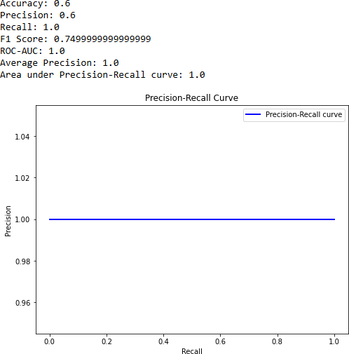

PRACTICAL – 05

AIM: Text Categorization
- Implement a text classification algorithm (e.g., Naïve Bayes or Support Vector Machines).
- Train the classifier on a labelled dataset and evaluate its performance.

CODE:

# Import necessary libraries
from sklearn.datasets import fetch_20newsgroups
from sklearn.feature_extraction.text import TfidfVectorizer from sklearn.model_selection import train_test_split
from sklearn.svm import SVC
from sklearn.metrics import accuracy_score, classification_report

# Load the 20 Newsgroups dataset
newsgroups = fetch_20newsgroups(subset='all', remove=('headers', 'footers', 'quotes'))

# Split the dataset into training and testing sets
X_train, X_test, y_train, y_test = train_test_split(newsgroups.data, newsgroups.target, test_size=0.2, random_state=42)

# Convert text data to TF-IDF features vectorizer = TfidfVectorizer()
X_train_tfidf = vectorizer.fit_transform(X_train) X_test_tfidf = vectorizer.transform(X_test)

# Train a Support Vector Machine (SVM) classifier svm_classifier = SVC(kernel='linear', C=1.0)

svm_classifier.fit(X_train_tfidf, y_train)

# Make predictions on the test set
y_pred = svm_classifier.predict(X_test_tfidf)

# Evaluate the performance of the classifier accuracy = accuracy_score(y_test, y_pred)
classification_rep = classification_report(y_test, y_pred, target_names=newsgroups.target_names)

# Print the results print(f"Accuracy: {accuracy:.2f}") print("\nClassification Report:") print(classification_rep)

OUTPUT:
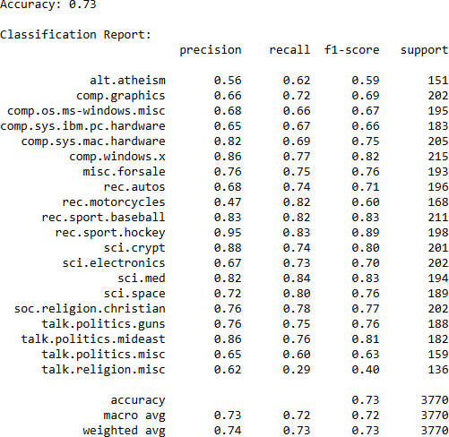

PRACTICAL – 06

AIM: Clustering for Information Retrieval
- Implement a clustering algorithm (e.g., K-means or hierarchical clustering).
- Apply the clustering algorithm to a set of documents and evaluate the clustering results.

CODE:

# Import necessary libraries
from sklearn.feature_extraction.text import TfidfVectorizer from sklearn.cluster import KMeans
from sklearn.metrics import silhouette_score

# Sample documents documents = [
"This is the first document.",
"This document is the second document.", "And this is the third one.",
"Is this the first document?", "The last document is here."
]

# Convert documents to TF-IDF matrix vectorizer = TfidfVectorizer()
X = vectorizer.fit_transform(documents) # Apply K-means clustering
num_clusters = 2 # You can adjust the number of clusters as needed n_init_value = 10 # You can adjust this value based on your needs

kmeans = KMeans(n_clusters=num_clusters, n_init=10) kmeans.fit(X)

# Get cluster labels cluster_labels = kmeans.labels_

# Calculate silhouette score using the original documents and cluster labels silhouette_avg = silhouette_score(X, cluster_labels)

# Print results
print("Cluster labels:", cluster_labels) print("Silhouette Score:", silhouette_avg)

OUTPUT:

PRACTICAL – 07

AIM: Web Crawling and Indexing
- Develop a web crawler to fetch and index web pages.
- Handle challenges such as robots.txt, dynamic content, and crawling delays.

CODE:

import requests
from bs4 import BeautifulSoup
from urllib.parse import urljoin, urlparse

start="https://www.w3schools.com/python/" base=urlparse(start).scheme+"://"+urlparse(start).netloc queue, visited=[start], set()
valid=lambda u:urlparse(u).scheme in("http","https") and urlparse(u).netloc

while queue and len(visited)<10: url=queue.pop(0)
if url in visited: continue try:
r=requests.get(url,timeout=5) if r.status_code!=200: continue print("Crawled:",url) visited.add(url)
for a in BeautifulSoup(r.text,"html.parser").find_all("a",href=True): link=urljoin(url,a['href'])
if link.startswith(base) and link not in visited and valid(link): queue.append(link)

except: pass

OUTPUT:
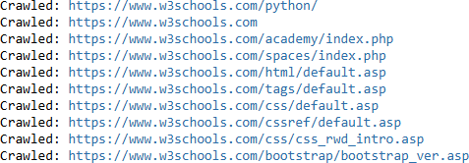

PRACTICAL – 08

AIM: Link Analysis and PageRank
- Implement the PageRank algorithm to rank web pages based on link analysis.
- Apply the PageRank algorithm to a small web graph and analyze the results.

CODE:

import numpy as np

def pagerank(G, d=0.85, eps=1e-8, it=100): n = len(G)
r = np.ones(n) / n out = G.sum(axis=1)

for _ in range(it): new = np.zeros(n) for i in range(n):
for j in range(n): if G[j][i]:
new[i] += r[j] / out[j]
new[i] = (1-d)/n + d * new[i]
if np.linalg.norm(new - r, 1) < eps: break
r = new return r

G = np.array([ [0,1,1,1],

[1,0,0,0],
[1,1,0,1],
[0,0,1,0]
])

for i,v in enumerate(pagerank(G),1): print(f"Page {i}: PageRank Score = {v:.4f}")

OUTPUT:
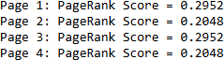

PRACTICAL – 09

AIM: Learning to Rank
- Implement a learning to rank algorithm (e.g., RankSVM or RankBoost).
- Train the ranking model using labelled data and evaluate its effectiveness.

CODE:

from sklearn.datasets import make_classification from sklearn.model_selection import train_test_split from sklearn.preprocessing import StandardScaler from sklearn.svm import SVC
from sklearn.metrics import ndcg_score

X,y = make_classification(n_samples=1000,n_features=10,n_classes=2,random_state=42) Xtr,Xte,ytr,yte = train_test_split(X,y,test_size=0.2,random_state=42)
sc = StandardScaler()
Xtr,Xte = sc.fit_transform(Xtr), sc.transform(Xte) model = SVC(kernel='linear').fit(Xtr,ytr)
pred = model.decision_function(Xte)
print("NDCG Score:", ndcg_score(yte.reshape(1,-1), pred.reshape(1,-1)))

OUTPUT:

